**Preliminary Research**

***TLDR: Sites with rooms in Concordia. The list of rooms and an idea for the room selection process.***

There are 3 sites on the Concordia campuses in which you can rent rooms. Sites and their respective rooms.

**Webster Library**

2nd floor

Being Renovated

3rd floor

LB-351, LB-353, LB-359

Plan: <http://library.concordia.ca/locations/images/lb3.png>

4th floor

LB-447, LB-449, LB-479, LB-481

Plan: <http://library.concordia.ca/locations/images/lb4.png>

5th floor

LB-518, LB-522, LB-547, LB-583

Plan: <http://library.concordia.ca/locations/images/lb5.png>

Total 11 rooms

**Vanier Library**

Regular Rooms

VL 301-10, VL 301-11, VL 301-22, VL 301-23, VL 301-24

Enhanced (Digital Collaboration)

VL 301-12, VL 301-13, VL 301-20, VL 301-21

Total 9 rooms

Plan: <http://library.concordia.ca/locations/images/VL-3.png>

**Grey Nuns**

Regular Rooms

B.101, B.102, B.106, B.120

Enhanced (Digital Collaboration)

B.104, B.108, B.109, B.110, B.111, B.121, B.122, B.123, B.124, B.125

Total: 14 rooms

A map of the floor can be found here.

<http://library.concordia.ca/locations/images/GN.png>

**Speculations**

Room Selection Process

An image like this one could be used to optimize room selection and help with visualization. There would be an interface right beside a plan of the floor listing all the hours and whether they are booked or not.

When you click on

Here is what the display system looks like.

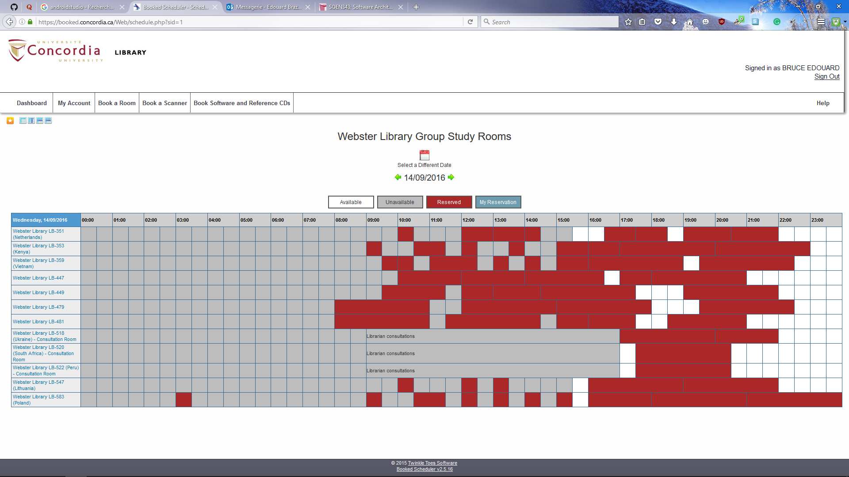

Where red means reserved. White is available and gray mean unavailable. Obviously the list of rooms is on the left.